SANDRA WENDY KYAVOA (ONLINE CLASS)

Who is facebook.com

Registrar:

RegistrarSafe, LLC

Registered On:

1997-03-29

Expires On:

2031-03-30

Updated On:

2022-01-26

Status:  
serverUpdateProhibited

Name Servers:

a.ns.facebook.com  
b.ns.facebook.com  
c.ns.facebook.com  
d.ns.facebook.com

**Registrant Contact**

Name:

Domain Admin

Organization:

Meta Platforms, Inc.

Street:

1601 Willow Rd

City:

Menlo Park

State:

CA

Postal Code:

94025

Country:

US

Phone:

+1.6505434800

Email:

email@fb.com

**Administrative Contact**

Name:

Domain Admin

Organization:

Meta Platforms, Inc.

Street:

1601 Willow Rd

City:

Menlo Park

State:

CA

Postal Code:

94025

Country:

US

Phone:

+1.6505434800

Email:

email@fb.com

**Technical Contact**

Name:

Domain Admin

Organization:

Meta Platforms, Inc.

Street:

1601 Willow Rd

City:

Menlo Park

State:

CA

Postal Code:

94025

Country:

US

Phone:

+1.6505434800

Email:

* @fb.com

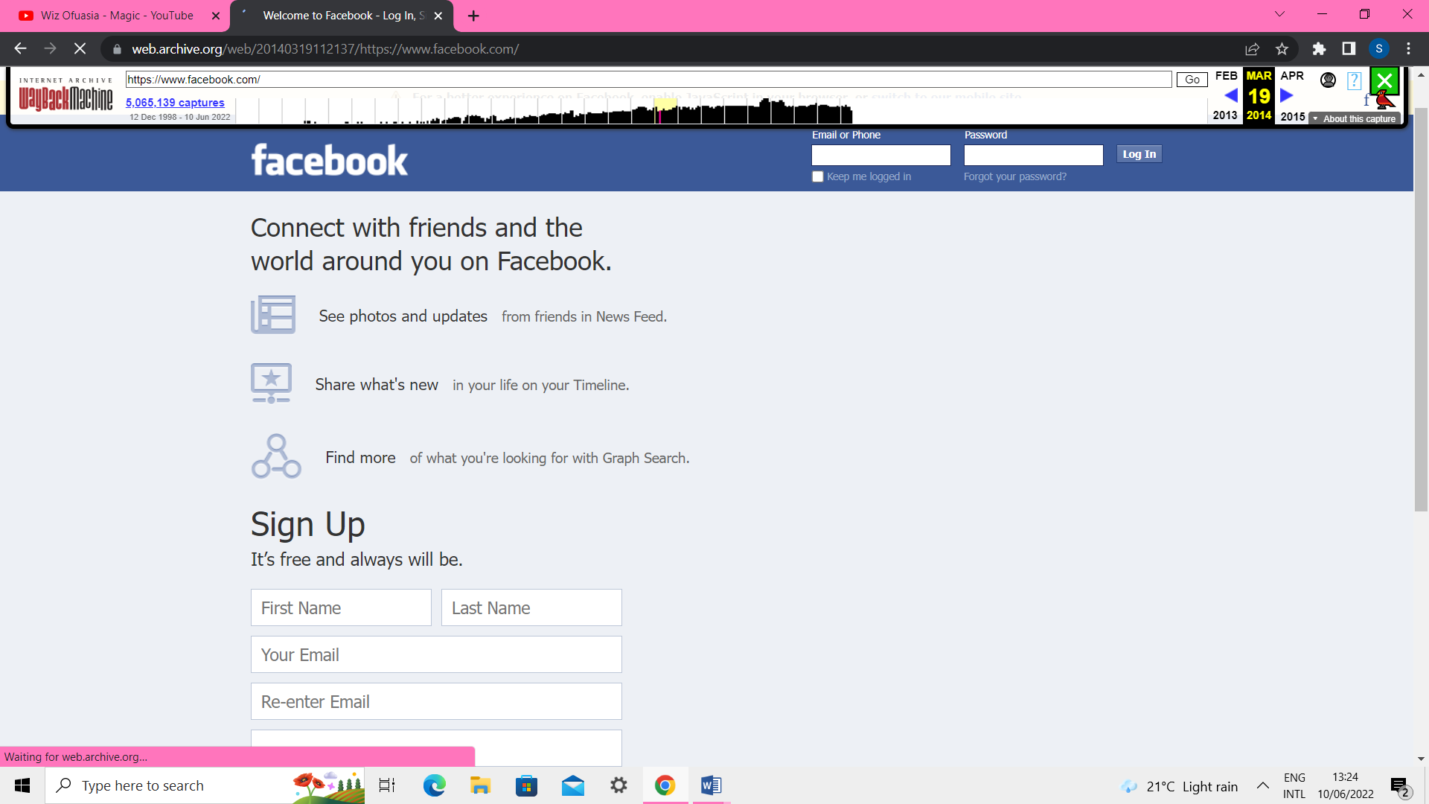

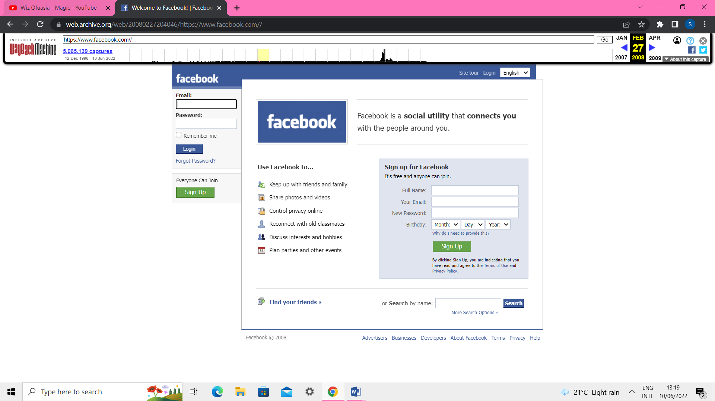

Who is twitter.com

Domain:

twitter.com

Registrar:

CSC Corporate Domains, Inc.

Registered On:

2000-01-21

Expires On:

2023-01-21

Updated On:

2022-01-17

Name Servers:

a.r06.twtrdns.net  
b.r06.twtrdns.net  
c.r06.twtrdns.net  
d.r06.twtrdns.net  
d01-01.ns.twtrdns.net  
d01-02.ns.twtrdns.net  
ns3.p34.dynect.net  
ns4.p34.dynect.net

**Registrant Contact**

Name:

Twitter, Inc.

Organization:

Twitter, Inc.

Street:

1355 Market Street

City:

San Francisco

State:

CA

Postal Code:

94103

Country:

US

Phone:

+1.4152229670

Fax:

+1.4152220922

Email:

email@twitter.com

**Administrative Contact**

Name:

Domain Admin

Organization:

Twitter, Inc.

Street:

1355 Market Street

City:

San Francisco

State:

CA

Postal Code:

94103

Country:

US

Phone:

+1.4152229670

Fax:

+1.4152220922

Email:

email@twitter.com

**Technical Contact**

Name:

Tech Admin

Organization:

Twitter, Inc.

Street:

1355 Market Street

City:

San Francisco

State:

CA

Postal Code:

94103

Country:

US

Phone:

+1.4152229670

Fax:

+1.4152220922

Email:

email@twit

Domain:

twitter.com

Registrar:

CSC Corporate Domains, Inc.

Registered On:

2000-01-21

Expires On:

2023-01-21

Updated On:

2022-01-17

Status:

clientTransferProhibited

Name Servers:

a.r06.twtrdns.net  
b.r06.twtrdns.net  
c.r06.twtrdns.net  
d.r06.twtrdns.net  
d01-01.ns.twtrdns.net  
d01-02.ns.twtrdns.net

